[UPT]
[AC]
[C-RO 4]

proiectAniversare
Design and Implementation of an Anniversary Website
Web Programming Course Project Report
Student: Ratiu Eric
Submission date: 11 October 2026
Repository URL and assessed commit: [https://github.com/JustEricGR/proiectAniversare]

Abstract
proiectAniversare is a personal anniversary website that allows a visitor to browse themed messages, photographs and optional music, while an administrator manages the content through a browser interface. The application uses HTML, CSS and JavaScript for the frontend, Supabase for authentication, relational data and image storage, and GitHub Actions for automated image uploads. The design separates the visitor experience from authenticated administration and avoids a custom application server. This report presents the requirements, architecture, data model, implementation and evaluation of the solution. The documented interface demonstrations use simulated database and media services; consequently, they do not establish successful integration with the live services. Identified limitations include conflicting CSS rules, incomplete database deployment documentation and non-atomic content updates. The project demonstrates an integrated approach to web programming, with further validation required before all requirements can be considered satisfied.
Keywords: web programming, JavaScript, Supabase, PostgreSQL, content management, GitHub Actions

Contents
1 Introduction 3
2 Requirements Analysis 3
3 System Architecture and Design 6
4 Implementation and User Interface 10
5 Testing and Evaluation 19
6 Deployment and Reproducibility 21
7 Future Development 21
8 Conclusion 23
References 24
Appendix A Code Listings 25
Appendix B Submission Completion Checklist 33

1 Introduction

1.1 Background and purpose
proiectAniversare is a personal website made as an anniversary gift. One person, the admin, prepares a set of surprises, and the other person, the visitor, opens them in a browser. A surprise is a page with photos, a short text and, if wanted, a song. The site must be easy to open from a link on a phone, and the admin has to be able to change everything on it without touching the code.
Two people use the site and they see different pages. The visitor starts on the landing page and continues to the visitor page, where they read the welcome screen, open the menu and open each surprise. The admin starts on the same landing page, signs in, and reaches a panel from which every text, colour, picture and menu button can be changed.

1.2 Objectives
The project aims to provide a mobile-friendly visitor experience, allow an administrator to maintain the site without changing source code, persist content in a hosted database, and automate the transfer of repository images into cloud storage. These objectives are evaluated through the requirements and evidence discussed in Sections 2 and 5.

1.3 Scope
Some things are deliberately left out. The site has exactly one admin account, created by hand in the Supabase dashboard, so there is no registration. Visitors cannot type or upload anything, there are no payments, and one database serves one site.

1.4 Report organisation
Section 2 defines the requirements. Section 3 explains the architecture and data design. Section 4 describes the implemented features and figures. Section 5 separates the available demonstration evidence from outstanding tests. Sections 6 and 7 address deployment and limitations. Code excerpts are retained in Appendix A.

2 Requirements Analysis

2.1 Functional requirements
Table 1 maps the functional requirements to the implementation locations identified in the project documentation. A code mapping does not, by itself, constitute a passed test.
Table 1 Functional requirements
ID | Requirement | Implemented in
FR-01 | The landing page offers two entries, one for the visitor and one for the admin | index.html
FR-02 | The welcome screen shows a full-screen background image, a title and a text, all set by the admin | client.html #startScreen, loadSettings() in client.js
FR-03 | A second section shows a second title, a text and an enter button on a background colour set by the admin | #welcomeColorSection, loadSettings()
FR-04 | The menu shows one button per surprise, in the order the admin created them | loadMenu(), renderMenu()
FR-05 | Opening a button shows its title, its photos, its text and an optional song | showContent(), renderContentImages(), renderText(), renderYoutube()
FR-06 | The song plays as audio only, with one play/pause button, loops, and stops when the visitor leaves the page | renderYoutube(), destroyYoutubePlayer()
FR-07 | The visitor can return to the menu from any content page | #backHomeBtn, showMenu()
FR-08 | The visitor needs no account | Public reads with the anon key
FR-09 | The admin signs in with email and password | login.html, db.auth.signInWithPassword()
FR-10 | The admin page redirects to the login page when there is no session | boot() in admin.js
FR-11 | The admin can sign out | logout()
FR-12 | The admin edits the welcome title, the enter-button text, the background image URL, three texts and two colours, and sees a preview of the background | loadSettings(), saveSettings(), renderBackgroundPreview()
FR-13 | The admin adds a menu button, which starts with empty content | addButton()
FR-14 | The admin edits a button's label, image list, text and YouTube link | selectButton(), addImageUrl(), renderImages(), saveCurrentContent()
FR-15 | The admin deletes a button after confirming | deleteButton()
FR-16 | URLs that are not http or https are rejected before saving | isValidUrl()
FR-17 | Every save reports success or the database error on the page | showStatus()
FR-18 | Photos committed to pozeAniversare are uploaded to cloud storage automatically | upload_images.yml, upload_images.mjs
FR-19 | The upload can also be started by hand | workflow_dispatch trigger
FR-20 | Files that are not images are skipped, and a failed upload fails the run | IMAGE_EXTENSIONS, process.exitCode = 1

2.2 Nonfunctional requirements
Table 2 records the quality objectives and their documented implementation mechanisms. Security, responsiveness and performance require the additional validation described in Section 5.
Table 2 Nonfunctional requirements
ID | Requirement | How the code meets it
NFR-01 | Only the admin can change data | Writes run under the signed-in Supabase session. The anon key in config.js is public, so the database itself must refuse anonymous writes with row-level security
NFR-02 | The secret key never reaches a browser | The service-role key exists only as a GitHub Actions secret, read by upload_images.mjs from the environment
NFR-03 | Text typed by the admin cannot inject HTML or scripts | Labels and texts are written with textContent and createElement; innerHTML is used only for fixed strings
NFR-04 | The site works on a phone and on a desktop | Viewport meta tag, CSS Grid with auto-fit, min() widths, media queries at 760 px and 600 px
NFR-05 | Pages load fast despite many photos | loading="lazy" on images, buttons and content fetched in parallel with Promise.all, 1-hour cache header on stored images, YouTube script loaded only when a song exists
NFR-06 | A broken link does not break a page | A failed image is removed (visitor) or labelled (admin); a YouTube error disables the music button and shows a message
NFR-07 | No custom application server to maintain | Static frontend and managed backend; service charges and limits depend on the selected hosting plans
NFR-08 | Content changes need no code change | Configured visitor content is edited through admin.html; landing-page labels remain in source and the content-colour defect is unresolved
NFR-09 | Image lists are read whatever format the database returns | normalizeImageUrls() accepts a JSON array, a JSON string and a PostgreSQL array literal

3 System Architecture and Design

3.1 Architecture overview
The site has three parts. The first is a set of static files, four HTML pages, one stylesheet and two JavaScript files, that run entirely in the browser. The second is Supabase, a hosted service that supplies the database, the sign-in and the file storage, and so plays the role of the whole backend. The third is a GitHub Actions job that copies the photos from the repository to the storage.
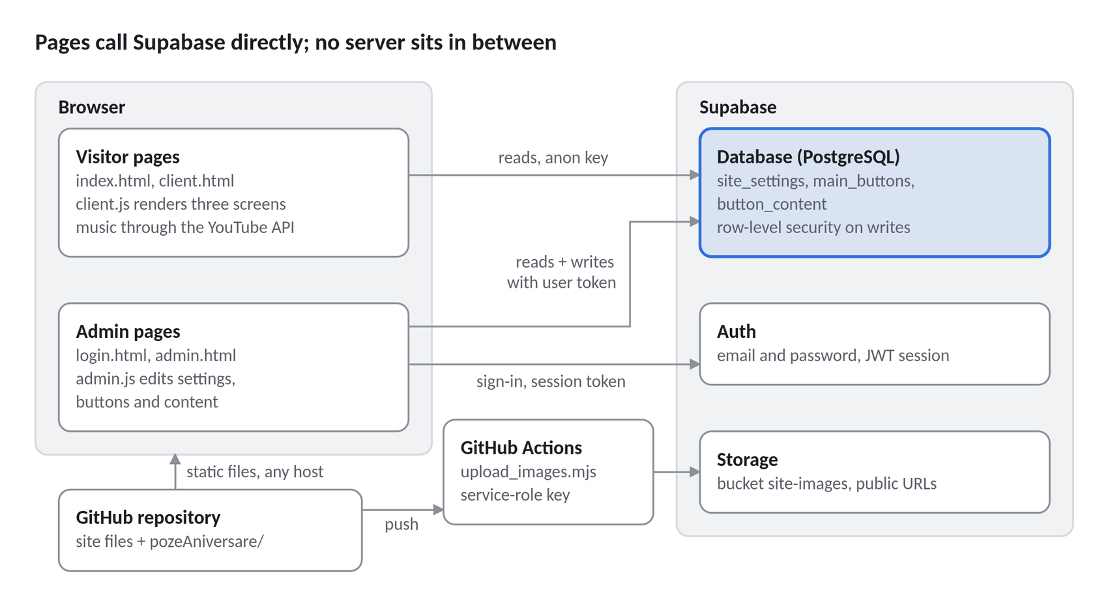
Figure 1. The three parts of the site and how they talk to each other.
The visitor's pages only read from the database, using a public key. The admin's pages sign in first and then read and write with the token of that session. Photos never pass through the browser on their way to storage: they are uploaded by GitHub Actions, which is the only place that holds the powerful service-role key.
The repository holds 1,986 lines of source in 11 files, next to a folder of 697 photos and 11 videos that weighs about 349 MB.

3.2 Frontend design
The frontend uses no framework. It is written in plain HTML5, one CSS file of 641 lines and ordinary JavaScript, and the only library it loads is supabase-js, the official client for Supabase, taken from the jsDelivr CDN. I am using a framework such as React to deal with an application that has many screens, shared components and a complex state.
This site has four pages and three screens of state, so the browser's own tools are sufficient.
I removed the build step by leaving the framework out: the files in the repository are exactly the files the browser receives.
Each page has one job. index.html is the landing page with two links. login.html is the sign-in form for the admin, with 22 lines of script written inside the page. client.html is the whole visitor experience and is driven by client.js, which has 377 lines. admin.html is the content management panel and is driven by admin.js, which has 430 lines. Every page that talks to the backend loads three scripts in the same order: the Supabase library, then config.js, which holds the address of the project and its public key, then the page's own script, whose first line creates the client object used for every request.
The visitor page changes screens without changing its address. client.html contains three <section> elements, one for the welcome screen, one for the menu and one for the content of a surprise. At any moment two of them carry the CSS class hidden, which sets display: none, and moving from one screen to another only adds and removes that class. The data is kept in ordinary variables: client.js remembers the buttons, their contents and the site settings, and admin.js remembers the settings, the buttons and the one being edited. Each variable is filled by one loading function and read by the functions that draw the page.
Drawing is done by hand. A function that draws a list first empties its container, then creates each element with document.createElement, sets its text with textContent and attaches its click handler with addEventListener. Using textContent instead of innerHTML for anything the admin types is what keeps the inserted values as text rather than interpreting them as HTML.
The layout relies on two CSS tools. Flexbox centres cards and lines up buttons, and CSS Grid arranges the menu and the admin panel. The menu grid is declared as repeat(auto-fit, minmax(230px, 1fr)), which means as many columns as fit, each at least 230 pixels wide, so the number of columns follows the width of the screen with no further rules. Two CSS media queries provide additional responsive layout adjustments: one targets the administrator interface at viewport widths up to 760 pixels, while the other targets the visitor interface at widths up to 600 pixels. Two small @keyframes animations add movement: the heart on the landing page pulses and the arrow on the welcome screen bounces.

3.3 Backend and access control
There is no server written for this project. Supabase is the backend, and the browser talks to it directly over HTTPS. Three of its services are used:
- Supabase Auth checks the admin's email and password and issues the session.
- Supabase database, which is PostgreSQL, stores the settings, the menu buttons and their content.
- Supabase Storage keeps the photos in a public bucket named site-images. The only code that runs outside a browser is upload_images.mjs, a Node.js script of 205 lines that GitHub Actions runs to fill that bucket.
Reading and writing data is done with the query builder of supabase-js.
A chain such as db.from("main_buttons").select("*").order("position") is converted by the library into one HTTPS request to a REST interface that Supabase generates from the tables, and the answer always arrives as a pair: the data and an error. The site uses a small set of these calls. It reads the single row of settings, lists the buttons in order and reads the content of the buttons. The admin additionally inserts a button, updates its label, deletes it, and saves settings and content with upsert, an operation that inserts a row if it is missing and updates it if it exists. Every call checks the error before it uses the data. In the admin panel the error text is shown on the page, and on the visitor page it is written to the browser console while the page keeps its default texts.
Signing in works with tokens. signInWithPassword returns a session made of an access token, which is a JWT, and a refresh token. The library keeps the session in the browser and adds the token to every later request, so the database can identify the signed-in user; policies must establish whether that user is the administrator.
admin.js checks whether the user is signed in. If not, it sends them to the sign-in page. This check alone does not secure the data. Anyone can view or bypass the website’s JavaScript. The database must enforce its own rules. These rules must allow only the designated administrator to change data, not every signed-in user.
This is why the site uses two keys with very different powers. The anon key in config.js is meant to be public: it only identifies the project and allows what the row-level security rules of the database allow. The service-role key ignores those rules. It is stored as a secret in GitHub Actions, it is read by the upload script from an environment variable, and it appears nowhere in the code of the site.

3.4 Data model
The data sits in three tables:
- site_settings holds a single row, with id equal to 1, that contains everything which themes the visitor page: the title, the label of the enter button, the address of the background picture, three texts and two colours.
- main_buttons holds one row for each menu button, with its label and a position used for ordering.
- button_content holds the content of one button in one row: the list of picture addresses, the text and the YouTube link, tied to its button by button_id. This description is reconstructed from the queries in the code and from the migration file supabase_update.sql, because the statements that created the tables are not in the repository.
The database is organised around the site settings, menu buttons and the content linked to each button.
The site needs only one set of settings. These are stored in a single row with id = 1. The upsert operation creates this row if it does not exist. Otherwise, it updates the existing row.
Menu buttons and their content are stored in separate tables. Each button has a label and a position in the menu. Its photos, text and music link are stored in the content table. The current application loads both tables when it opens the menu.
Each button’s image links are stored as an ordered list in one database field. This keeps the photos in the intended display order. The application reads and saves the whole list together, so this project does not need a separate row for each image.
The image files are kept in cloud storage. The database stores only their web addresses. The browser uses these addresses to load the images. Storage also provides caching instructions, which let the browser reuse downloaded images instead of downloading them again.
The database update script adds five columns and gives them default values. It uses ADD COLUMN IF NOT EXISTS to check whether each column already exists. This allows the script to run again without trying to create duplicate columns.

The intended relationship is one main_buttons record to one button_content record through button_id. The uniqueness, foreign-key and deletion constraints must be verified against an exported schema; the query excerpts alone do not confirm their configuration.
Table | Purpose | Fields identified in the documentation
site_settings | Single site configuration | id; client_title; client_button_text; background_image_url; welcome_top_text; welcome_second_title; welcome_bottom_text; welcome_background_color; content_background_color; updated_at
main_buttons | Menu entries and ordering | id; label; position
button_content | Content associated with a menu entry | button_id; image_urls; custom_text; youtube_url; updated_at

3.5 Technology selection
Supabase is suitable for this project because it provides the database, sign-in service and photo storage in one place. There is no need to build and maintain a separate application server. The website uses the Supabase JavaScript library to read and save data directly from the browser.
Visitors need to view content without signing in. Only the administrator should be able to change it. Supabase supports this through sign-in and database access rules. These rules must be configured to allow changes only by the designated administrator. Because the database enforces them, visitors cannot bypass them by changing the website’s JavaScript.
Supabase also stores the site’s photos. Each photo has a public web address that the website uses to display it.
The database uses PostgreSQL. It stores the menu buttons, their display positions and their linked content. Database rules can ensure that each content record belongs to a valid button and that each button has no more than one content record. The application uses the saved positions to display the buttons in order.
Changes to the database structure are made through SQL update scripts. The data can also be exported if the project moves to a different backend later.
Other approaches were considered. A custom Node.js or PHP backend would require additional development and maintenance. A document database would organise the data differently. Storing content in JSON files in the repository would mean editing and publishing those files whenever the content changes.
Supabase was selected based on how well it fits the project’s needs. No performance tests or detailed cost comparisons were carried out between these options.

4 Implementation and User Interface
This section shows how the website looks and works. The screenshots were taken by running the site’s HTML, CSS and JavaScript in a browser. Test versions of the database and YouTube player were used, along with sample pictures and text. The screenshots show the site’s actual design, but do not confirm that the live database or YouTube connection works. Each code example comes from the project repository and includes its file name and line numbers.
The line that holds only an ellipsis - marks lines that were left out.
Figures 1–10 are retained from the project documentation. Code excerpts are collected in Appendix A, where filenames and line ranges identify their original locations. These line ranges should be checked against the final submitted commit.

4.1 Landing page
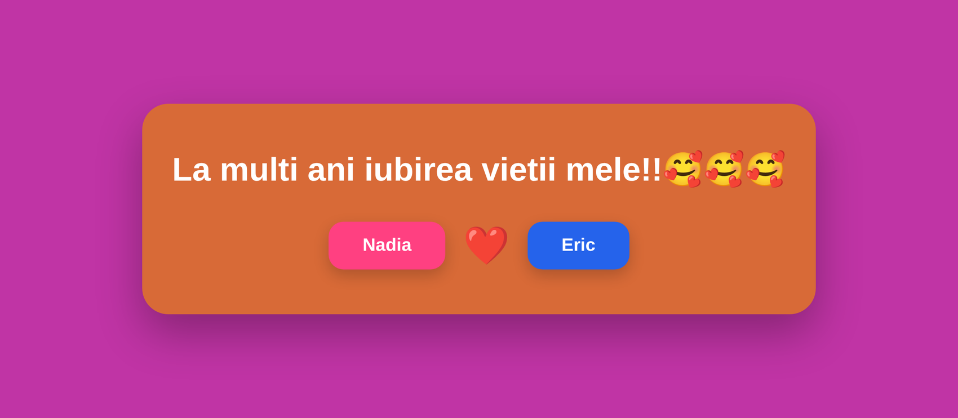
Figure 2. The landing page, with one entry for the visitor and one for the admin.
The first page is deliberately tiny: a card with a greeting and two links, one for each person. The link named Nadia opens the visitor page and the link named Eric opens the sign-in page. Both are ordinary <a> elements styled as buttons, so the page needs no JavaScript at all.
See Listing A1 in Appendix A (index.html, lines 12–20).
The heart between the two buttons is animated in CSS alone. The heartPulse animation scales and tilts it slightly, and infinite alternate plays it forwards and backwards without end.
See Listing A2 in Appendix A (style.css, lines 571–580).

4.2 Welcome screen
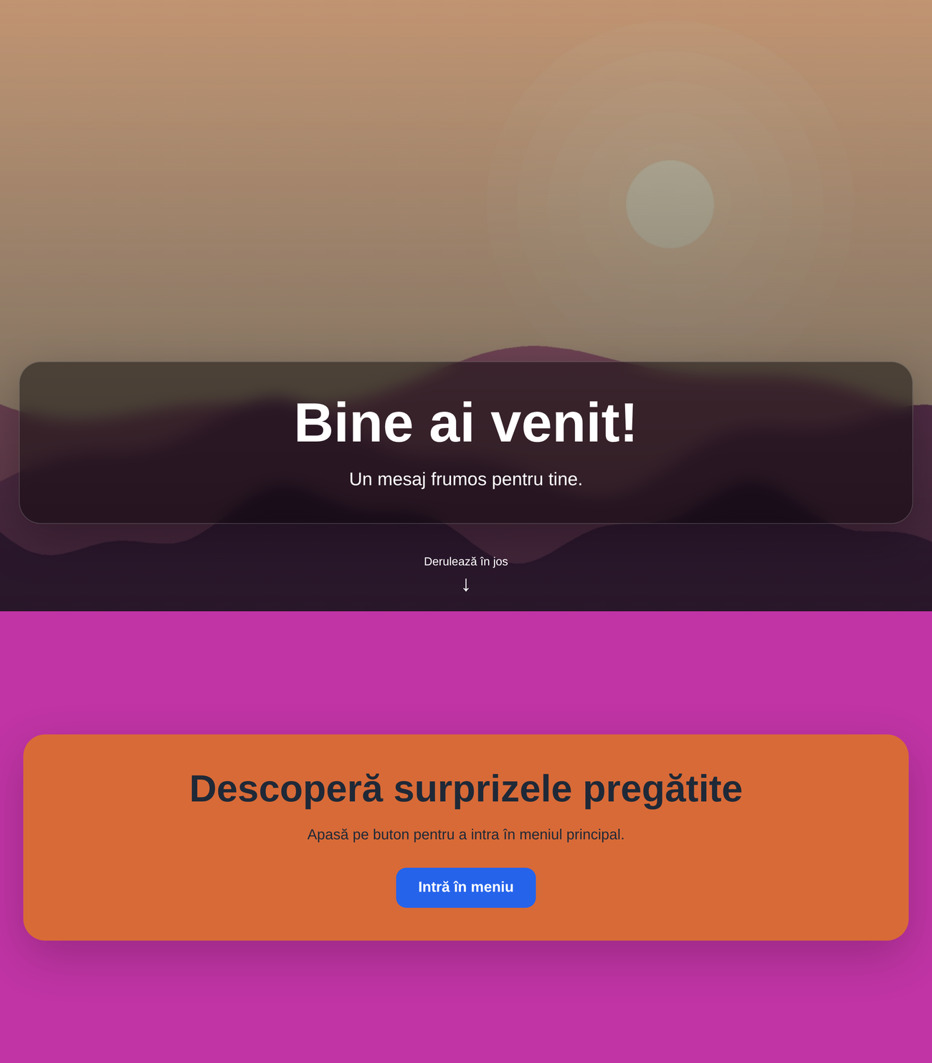
Figure 3. The welcome screen from top to bottom: the picture section, then the coloured section with the button that opens the menu.
The welcome screen is made of two sections placed one under the other. The first fills the screen with the background picture and carries the title and the first message, and an arrow invites the visitor to scroll. The second has a background colour, a second title, a second message and the button that opens the menu. The HTML already holds default texts, so the page is readable even before the database answers.
See Listing A3 in Appendix A (client.html, lines 16–42).
As soon as the page has loaded, loadSettings() reads the row of settings and writes each value into the page. Texts go in through textContent. The colours and the picture are written into the style of the elements, and the picture is combined with a dark gradient so that the darkened background improves white-text contrast, which still requires checking for the selected photo. The same background is then given to the menu screen.
See Listing A4 in Appendix A (client.js, lines 54–67).

4.3 Dynamic menu
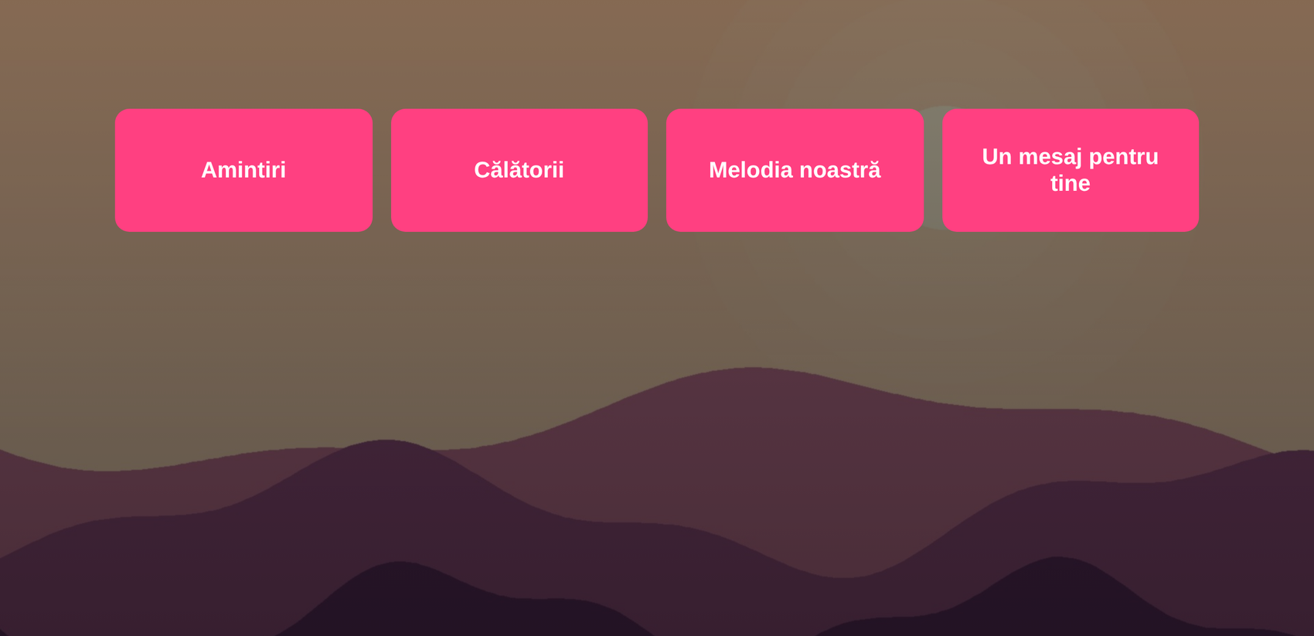
Figure 4. The menu: one button for each surprise, over the same background picture.
The menu does not exist in the HTML. client.html contains only an empty container for it.
See Listing A5 in Appendix A (client.html, lines 46–54).
When the page loads, loadMenu() sends two requests at the same time with Promise.all, one for the buttons sorted by position and one for the content of all buttons, and keeps both answers in memory. renderMenu() then fills the container with one button for each row, so the buttons appear in the order in which the admin created them. Each button remembers its own row through its click handler.
See Listing A6 in Appendix A (client.js, lines 98–116).
The arrangement in columns comes from a single CSS rule. With auto-fit the browser decides how many columns of at least 230 pixels fit in the available width.
See Listing A7 in Appendix A (style.css, lines 422–427).

4.4 Surprise content and navigation
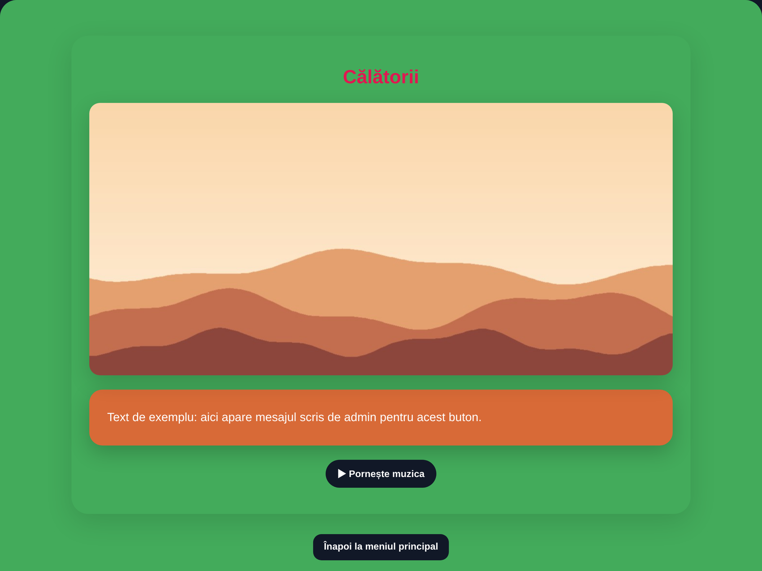
Figure 5. A surprise page with its title, a picture, the text, the music control and the button that returns to the menu.
The content screen is again an empty frame in the HTML: a title, three containers and, outside the section, the button that leads back to the menu.
See Listing A8 in Appendix A (client.html, lines 57–70).
Clicking a menu button calls showContent(). No new request is made, because the content of every button was loaded together with the menu, so the function only looks up the right row in memory. It then hides the menu, shows the content section and the back button, and hands the three parts of the content to three small functions.
See Listing A9 in Appendix A (client.js, lines 129–147).
The pictures are created one by one. Each gets a description for screen readers, the setting loading = "lazy", which lets the browser postpone pictures that are still off screen, and an error handler that removes the picture if its address no longer works, so a dead link leaves no broken icon behind.
See Listing A10 in Appendix A (client.js, lines 155–167).

4.5 Music controls

Figure 6. The music control once the player is ready.
The song is a YouTube video played without its picture.
renderYoutube() first extracts the identifier of the video from the link; it understands the short youtu.be form and the watch, shorts, embed and live forms of youtube.com and music.youtube.com. It then loads the YouTube IFrame Player API, once per visit, and creates a player one pixel in size that is placed off screen. The options switch off the controls and autoplay, and loop together with playlist set to the same video makes a single video repeat.
See Listing A11 in Appendix A (client.js, lines 249–262).
The visitor sees one button. It stays disabled until the player reports that it is ready, and a click asks the player for its state and then pauses or plays. Starting from a click matters, because browsers block sound that starts by itself. When the visitor returns to the menu, showMenu() destroys the player and the song stops.
See Listing A12 in Appendix A (client.js, lines 290–300).

4.6 Administrator authentication
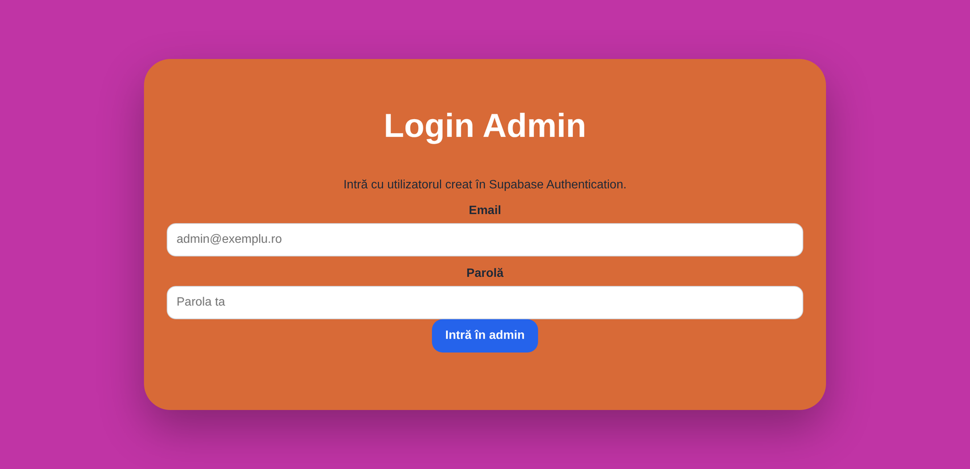
Figure 7. The sign-in page for the admin.
The sign-in page is a form with two fields, a button and an empty line for messages.
See Listing A13 in Appendix A (login.html, lines 14–21).
Its script sends the email and the password to Supabase Auth. If Supabase refuses them, its message is shown in red under the button, and if it accepts them the browser moves to the admin page.
See Listing A14 in Appendix A (login.html, lines 31–48).
The admin page checks the session before displaying its interface.
boot() asks for the current session and, when there is none, goes back to the sign-in page before anything is shown. The panel itself starts with the class hidden and is revealed only after this check. Opening admin.html without a session in the test browser did end on login.html.
See Listing A15 in Appendix A (admin.js, lines 11–25).

4.7 Site settings administration
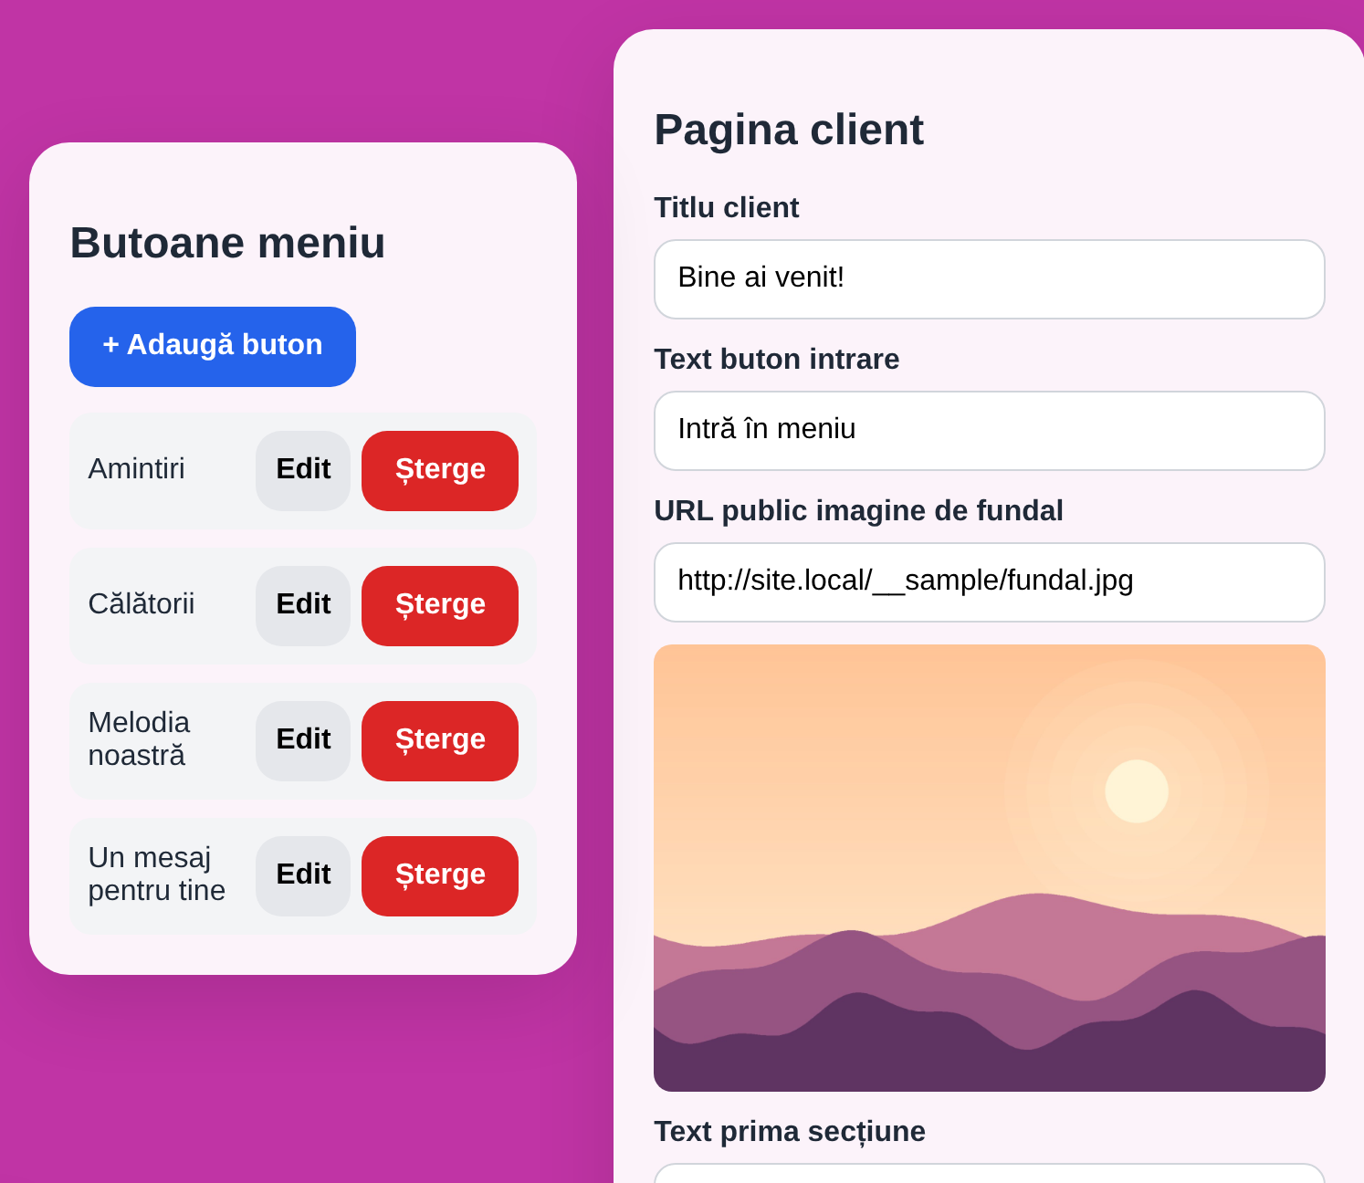
Figure 8. The admin panel: the list of menu buttons on the left and the form for the welcome screen on the right.
The panel has two columns, with the list of menu buttons on the left and the forms on the right. The first form edits the welcome screen. Each field is an ordinary labelled input, and the box under the background address shows a preview of the picture, or a message if the address cannot be loaded.
See Listing A16 in Appendix A (admin.html, lines 31–44).
Saving sends everything in one request.
saveSettings() first checks that the background address is a real http or https address, then calls upsert on the row with id 1, sending the eight values of the form and the time of the change.
Because of .select("*").single() the same request returns the saved row, which replaces the copy held in memory, and a status line under the button reports the result.
See Listing A17 in Appendix A (admin.js, lines 112–127).

4.8 Content editing
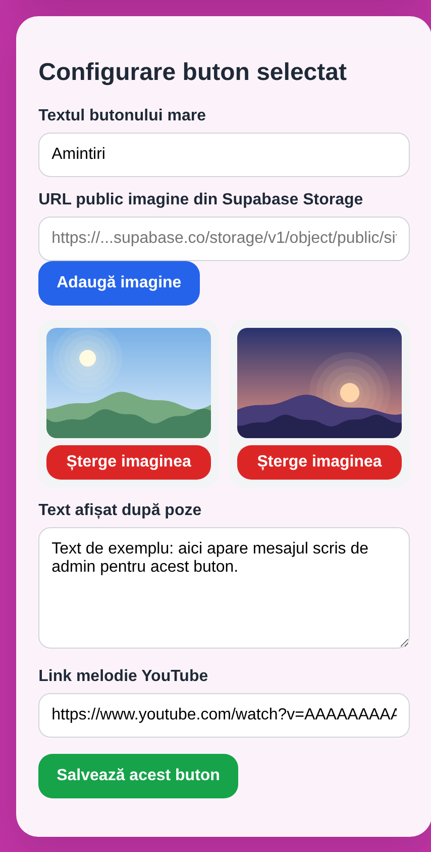
Figure 9. The editor of a menu button, with its label, its pictures, its text and its song.
Choosing Edit next to a button loads its content and opens the second form, which stays hidden until then.
See Listing A18 in Appendix A (admin.html, lines 86–100).
Pictures are added by address.
addImageUrl() checks the address, ignores one that is already in the list and adds the new one to the list held in memory. The thumbnails are redrawn at once, each with its own remove button, but nothing saves in the database until the admin presses the save button.
See Listing A19 in Appendix A (admin.js, lines 266–281).
Saving takes two requests. The first updates the label in main_buttons, and the second, shown below, saves the pictures, the text and the song in button_content with an upsert keyed on button_id.
See Listing A20 in Appendix A (admin.js, lines 343–353).
A new button is created from the top of the list on the left: the page asks for a label, inserts the row with the next position and creates an empty content row for it, then opens it in the editor. Deleting asks for a confirmation first and then removes the row from main_buttons.

4.9 Responsive layout
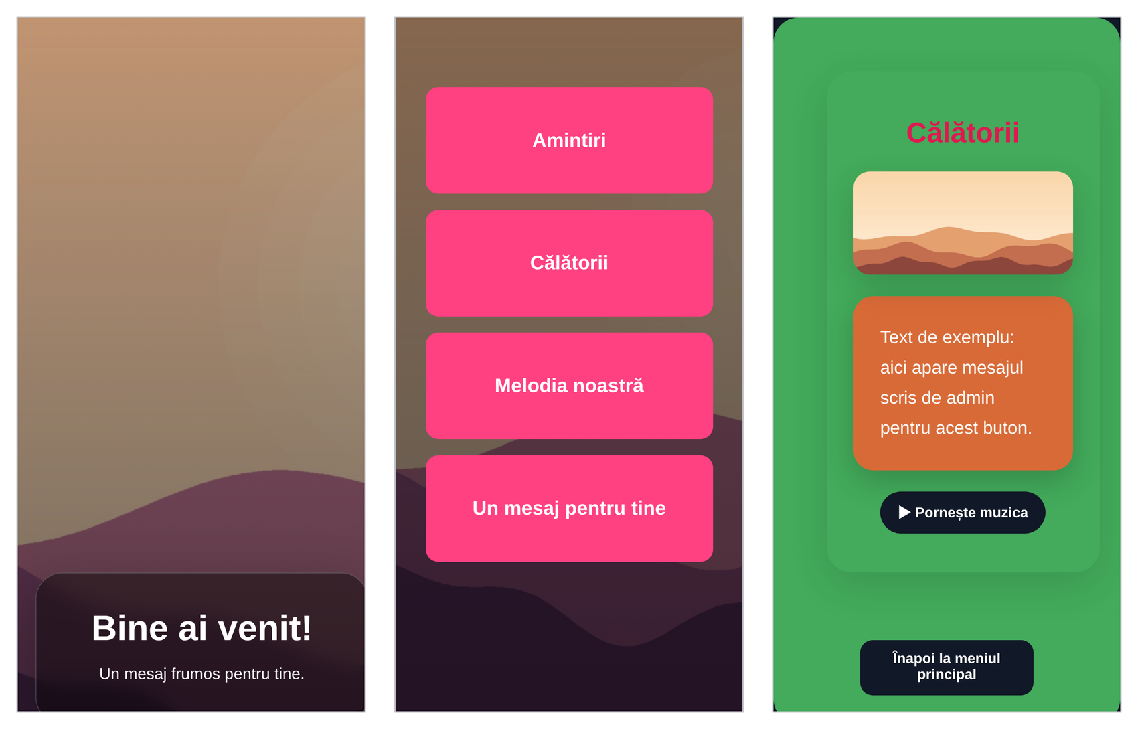
Figure 10. The welcome screen, the menu and a surprise at the width of a phone (390 pixels).
The visitor pages are meant to be opened from a link on a phone. Every page starts with the viewport tag, which tells a phone to use its real width instead of pretending to be a desktop screen.
See Listing A21 in Appendix A (client.html, line 5).
Below 600 pixels, a media query turns the menu into a single column, tightens the paddings and lets the pictures use their full height.
See Listing A22 in Appendix A (style.css, lines 484–493).

4.10 Automated image uploads
This feature runs on GitHub’s servers, so there is no webpage to show. The workflow starts automatically when changes to the photo folder, upload script or workflow file are pushed to the main branch. It can also be started manually.
See Listing A23 in Appendix A (.github/workflows/upload_images.yml, lines 3–12).
Its last step runs the upload script and hands it the address of the project and the service-role key from the secrets of the repository, so the workflow reads the key from a repository secret instead of hard-coding it.
See Listing A24 in Appendix A (.github/workflows/upload_images.yml, lines 33–41).
The script checks the folder and uploads files with these image extensions: jpg, jpeg, png, webp, gif, svg and avif. It skips all other files. The setting upsert: true allows an uploaded file to replace an existing file with the same name. The cacheControl setting tells browsers to keep a copy of each image for one hour.
See Listing A25 in Appendix A (upload_images.mjs, lines 137–143).
The script writes each image’s public web address to the upload log. It then reports how many files were uploaded, skipped or failed. If any upload fails, GitHub Actions marks the run as failed.
The administrator copies an image address from the log into a button’s content using the admin panel. Saving that content stores the address in the database, allowing the website to display the image.

5 Testing and Evaluation

5.1 Evaluation method
The evaluation includes a review of the code and browser tests using test versions of Supabase and the YouTube player. The screenshots use sample pictures and text. These tests show the page layout and how some controls work. They do not confirm that real sign-in, database access rules, file uploads or music playback work correctly. The results below separate what was observed from what still needs testing.

5.2 Reported observations
Area | Reported evidence | Assessment
Session navigation | Opening admin.html without a session redirected to login.html in the test browser. | Interface check only; database write restrictions remain unverified.
Visitor responsiveness | Figure 10 shows visitor screens at 390 pixels. | Visual evidence at one width; not a full browser or accessibility test.
Content colour | The selected colour was assigned inline but the rendered section remained green. | Known defect caused by an overriding CSS rule.
Admin layout | Header placement, contrast and mobile overflow problems were documented. | Known defects caused by a selector also matching the admin page.

5.3 Tests required for final validation
The following are proposed test cases, not completed results. We need to record the environment, execution date, actual outcome and supporting evidence for each test before claiming a pass.
Test | Procedure and expected result | Requirements
T01 | Open visitor pages, load settings and navigate through each surprise and back; saved content and ordering should be correct. | FR-01–08
T02 | Use valid and invalid credentials, sign out and reopen administration; authorised access should succeed and unauthenticated access should redirect. | FR-09–11
T03 | Attempt direct anonymous and non-admin database writes; all should be denied by database policies. Verify permitted reads. | NFR-01
T04 | Create, edit and delete an entry; reload and confirm persistence, content cleanup and stable ordering. | FR-12–15
T05 | Submit invalid URLs, duplicate images and HTML-like text; inspect rejection and literal rendering. | FR-16; NFR-03
T06 | Run against real YouTube services; verify play, pause, looping, unavailable media and cleanup on return. | FR-06; NFR-06
T07 | Test desktop and mobile widths, keyboard operation, labels, contrast and horizontal overflow. | NFR-04
T08 | Run image workflow automatically and manually, including a rejected file and failed upload; verify logs and exit status. | FR-18–20
T09 | Simulate a save failure and inspect stored label/content consistency and visible errors. | FR-17
T10 | Measure page load and image behaviour with representative content; record network and device conditions. | NFR-05

5.4 Assessment against the objectives
The design covers the main goals: visitors can browse the site, the administrator can edit content, and images can be uploaded automatically.
However, some CSS problems remain. The administrator’s selected background colour does not always appear, and the admin panel does not display correctly on smaller screens.
The report also lacks the full database setup and access rules. Without these, it is not possible to confirm that only the administrator can change data or that another person can recreate the same database correctly.
Finally, the report contains no speed measurements or recorded tests showing that the complete website works with the real services. These checks still need to be completed and documented.

6 Deployment and Reproducibility

6.1 Prerequisites
A Supabase project, static HTTP hosting, a GitHub repository with Actions enabled and a manually created administrator account are required. To be recorded (for deployment purposes): actual runtime and dependency versions, hosting provider and repository commit used for assessment. The full database schema and policies must be supplied alongside supabase_update.sql to make installation reproducible.

6.2 Configuration and execution
Create the three tables using the final exported schema, apply supabase_update.sql, and configure row-level security. Allow the intended public reads and restrict writes to the designated administrator; a general signed-in-user rule alone does not express the single-admin requirement.
Create the public site-images bucket and configure the administrator account in Supabase Auth. Set the project URL and public anon key in config.js. Keep the service-role key out of browser files.
Add SUPABASE_URL and SUPABASE_SERVICE_ROLE_KEY as GitHub repository secrets. Commit images under pozeAniversare and trigger the upload workflow. Copy the generated public image URLs into the administrator editor.
Serve the project over HTTP, for example with python -m http.server from the repository directory. Open the site through the local server URL, sign in, configure the welcome screen and create content entries.
Deploy the static files to the selected host and run the live validation cases in Section 5. Record the deployment URL and configuration instructions with the submission.

7 Future Development
The application described in this report is phase 1: a single anniversary website with one administrator. Development continues in two further phases. Phase 2 turns the website into a platform that hosts many couples, and phase 3 adds an optional paid styling tier. Phase 2 is designed in detail in docs/multiuser-design.md and docs/architecture.html in the repository; phase 3 is only outlined here.

7.1 Phase 2: multi-user platform

7.1.1 Goal and roles
Phase 2 hosts many independent anniversary sites in one deployment. Each site belongs to a pair of people. Three roles are defined:
- Master admin: the platform owner. Creates, suspends and deletes pairs, invites people and can repair the content of any pair. This role can only be granted from the Supabase SQL editor, never from a page.
- Pair admin: the partner who builds the surprises. Edits the settings, menu buttons, photos, texts and music of their own pair only.
- Pair user: the partner who receives the surprises. Views their pair's site and cannot edit it. Signs in with a magic link sent by email, so no password has to be remembered.
A pair has exactly one admin and one user. A person may belong to several pairs, so two partners can each run a site for the other. Accounts are invite-only and public sign-up is disabled.

7.1.2 Architecture
The frontend stays a set of static pages and Supabase remains the backend. Two pages are added: master.html, the console in which the master admin manages pairs and invitations, and accept.html, which completes an invitation. The admin and visitor pages receive the pair through the address (for example client.html?pair=eric-nadia), and every query is filtered by that pair. After signing in, login.html reads the user's roles and sends the master admin to the console, a pair admin to their panel and a pair user to their site.
The only new server-side component is a Supabase Edge Function that sends invitations. It is needed because inviting a user by email requires the service-role key, which must never reach a browser. The function checks that the caller is the master admin, asks Supabase Auth to send the invitation and records the membership.

7.1.3 Data model and access control
Five tables are added: pairs, pair_members, platform_admins, invites and profiles. The existing tables site_settings, main_buttons and button_content receive a pair_id column. site_settings changes from a single row with id 1 to one row per pair. Foreign keys with ON DELETE CASCADE ensure that deleting a pair removes its settings, buttons, content and invitations, which also resolves the related-content cleanup question left open in phase 1.
Isolation between pairs is enforced by row-level security in the database, not by the JavaScript. Two helper functions, is_master() and pair_role(pair_id), are used by every policy: members of a pair and the master admin may read its rows, and only the pair admin and the master admin may write them. Because pair_role() ignores suspended pairs, suspending a pair locks its members out immediately. The photo bucket becomes private, photos are stored under pairs/<pair_id>/, and storage policies apply the same rules. Pages display photos through signed addresses created when the page loads, so the database stores storage paths instead of full addresses.

7.1.4 Migration of the existing site
The existing site becomes the first pair, eric-nadia. Its owner becomes both the admin of that pair and the master admin, and the existing rows and photos are assigned to the pair. The old visitor address redirects to the new one, so the visitor sees no change. The SQL that creates the current tables is exported into a supabase/migrations folder in the repository, which also makes the deployment described in Section 6 reproducible.

7.1.5 Delivery stages
- Hardening: disable public sign-up, export the current schema and policies, and confirm that anonymous writes are refused.
- Data layer: add the new tables, helper functions and policies, and move the existing data into the first pair. The site behaves exactly as before.
- Pair-scoped pages: pair routing in the address, magic-link sign-in for the pair user and role-based routing after sign-in.
- Master console: master.html, the invitation Edge Function and accept.html.
- Uploads: photo upload directly in the admin panel, replacing the GitHub Actions step for everyday use. The workflow remains as a bulk import tool for the master admin.
- Polish: storage quotas per pair, deletion of a pair together with its files, and a custom email provider for invitations.

7.1.6 Evaluation of phase 2
Phase 2 adds test cases to those in Section 5.3: every role attempts every action directly against the database interface rather than through the pages; a pair admin attempts to read and write another pair's rows and photos by identifier; a suspended pair is checked to be unreachable by its members; and the invitation flow is tested for new and existing email addresses. After the migration, the existing site must render as it did before.

7.2 Phase 3: paid styling option
Phase 3 is a later, optional extension that is not designed in detail yet. It would add a paid tier that gives pair admins more ways to style their site, such as built-in themes, decorative frames for photos and additional layouts for the menu and content pages. Pairs on the free tier would keep the current styling options.
The platform would record which pairs have the paid tier and offer the extra styles only to them. The payment provider, pricing and the exact set of styles are left open and will be decided after phase 2 is in use.

8 Conclusion
proiectAniversare began as a personal anniversary website that combines a static browser interface with hosted authentication, database and storage services. Phase 1 demonstrates DOM manipulation, responsive CSS, asynchronous data access, authenticated content administration and automated asset publishing.
Phase 2 turns the website into a multi-user platform in which a master admin hosts many pairs, each with its own admin and recipient, and keeps their data apart through row-level security enforced by the database. Phase 3 outlines an optional paid tier for richer styling. Building phase 2 also addresses the main gaps of phase 1: the database schema and policies become part of the repository, related content is deleted consistently, and access rules are tested directly against the database. Together, these phases move the project from a single gift to a platform that other couples can use.

References
Complete the bibliography in the citation style required by the course. Record the exact documentation pages and versions actually consulted, and add matching in-text citations in the relevant design and implementation sections. The following entries identify source categories to complete; they are not a claim that these sources were consulted.
Project source repository — Ratiu Eric. proiectAniversare. [Repository URL, assessed commit and year].
Supabase documentation [Exact pages used for JavaScript client, authentication, row-level security and Storage; URLs and access dates].
Web platform documentation [Exact HTML, CSS and JavaScript references used; URLs and access dates].
GitHub Actions documentation [Workflow syntax and repository secrets pages used; URLs and access dates].
YouTube IFrame Player API documentation [Exact reference and applicable requirements consulted; URLs and access dates].

Appendix A Code Listings
The following excerpts are reproduced from the original project documentation. They are partial listings, not complete runnable files. Original filenames and line ranges are retained for traceability.

Listing A1
index.html, lines 12–20
<div class="center-card">
<h1>La multi ani iubirea vietii mele!!🥰🥰🥰</h1>
<div class="home-actions">
<a href="client.html" class="big-link love-btn nadia-btn">Nadia</a>
<span class="big-heart">❤️</span>
<a href="login.html" class="big-link love-btn eric-btn">Eric</a>
</div>
</div>

Listing A2
style.css, lines 571–580
.big-heart {
font-size: 50px !important;
line-height: 1 !important;
animation: heartPulse 1.2s infinite alternate ease-in-out !important;
}
@keyframes heartPulse {
0% { transform: scale(1); }
100% { transform: scale(1.25) rotate(4deg); }
}

Listing A3
client.html, lines 16–42
<section id="welcomeImageSection" class="welcome-image-section">
<div class="welcome-overlay"></div>
<div class="welcome-first-box">
<h1 id="clientTitle">Bine ai venit!</h1>
<p id="welcomeTopText">Un mesaj frumos pentru tine.</p>
</div>
<div class="scroll-indicator">
<span>Derulează în jos</span>
<strong>↓</strong>
</div>
</section>
<!-- A doua secțiune: culoare custom + al doilea text box + intră în meniu -->
<section id="welcomeColorSection" class="welcome-color-section">
<div class="welcome-second-box">
<h2 id="welcomeSecondTitle">Descoperă surprizele pregătite</h2>
<p id="welcomeBottomText">
Apasă pe buton pentru a intra în meniul principal.
</p>
<button id="enterMenuBtn" class="primary-btn enter-menu-btn" type="button">
Intră în meniu
</button>
</div>
</section>

Listing A4
client.js, lines 54–67
$("welcomeColorSection").style.backgroundColor =
data.welcome_background_color || "#d319b7";
$("contentScreen").style.backgroundColor =
data.content_background_color || "#d319b7";
if (data.background_image_url) {
const background =
`linear-gradient(rgba(0,0,0,.18), rgba(0,0,0,.42)), ` +
`url("${data.background_image_url}")`;
$("welcomeImageSection").style.backgroundImage = background;
$("menuScreen").style.backgroundImage = background;
}

Listing A5
client.html, lines 46–54
<section id="menuScreen" class="menu-page hidden">
<div class="menu-overlay"></div>
<div class="menu-shell">
<div class="card menu-card">
<div id="menuButtons" class="menu-buttons"></div>
</div>
</div>
</section>

Listing A6
client.js, lines 98–116
function renderMenu() {
const box = $("menuButtons");
box.innerHTML = "";
if (!buttons.length) {
box.innerHTML = "<p>Momentan nu există butoane configurate.</p>";
return;
}
buttons.forEach((btn) => {
const button = document.createElement("button");
button.type = "button";
button.className = "menu-button";
button.textContent = btn.label;
button.addEventListener("click", () => showContent(btn));
box.appendChild(button);
});
}

Listing A7
style.css, lines 422–427
.menu-buttons {
display: grid;
grid-template-columns: repeat(auto-fit, minmax(230px, 1fr));
gap: 18px;
margin-top: 24px;
}

Listing A8
client.html, lines 57–70
<section id="contentScreen" class="content-page hidden">
<div class="container content-container">
<div class="card content-view">
<h1 id="contentTitle"></h1>
<div id="imagesContainer" class="content-images"></div>
<div id="textContainer"></div>
<div id="youtubeContainer"></div>
</div>
</div>
</section>
<div id="backHomeBox" class="bottom-center hidden">
<button id="backHomeBtn" type="button">Înapoi la meniul principal</button>
</div>

Listing A9
client.js, lines 129–147
function showContent(btn) {
const content =
contents.find(
(item) => String(item.button_id) === String(btn.id)
) || {};
$("startScreen").classList.add("hidden");
$("menuScreen").classList.add("hidden");
$("contentScreen").classList.remove("hidden");
$("backHomeBox").classList.remove("hidden");
$("contentTitle").textContent = btn.label;
renderContentImages(content.image_urls, btn.label);
renderText(content.custom_text);
renderYoutube(content.youtube_url);
window.scrollTo({ top: 0, behavior: "smooth" });
}

Listing A10
client.js, lines 155–167
urls.forEach((url, index) => {
const img = document.createElement("img");
img.src = url;
img.alt = `${label} - imagine ${index + 1}`;
img.loading = "lazy";
img.onerror = () => {
console.error("Imagine indisponibilă:", url);
img.remove();
};
container.appendChild(img);
});

Listing A11
client.js, lines 249–262
youtubePlayer = new window.YT.Player(playerElement.id, {
height: "1",
width: "1",
videoId,
playerVars: {
autoplay: 0,
controls: 0,
rel: 0,
modestbranding: 1,
playsinline: 1,
loop: 1,
playlist: videoId
},

Listing A12
client.js, lines 290–300
musicButton.addEventListener("click", () => {
if (!youtubePlayer) return;
const state = youtubePlayer.getPlayerState();
if (state === window.YT.PlayerState.PLAYING) {
youtubePlayer.pauseVideo();
} else {
youtubePlayer.playVideo();
}
});

Listing A13
login.html, lines 14–21
<label for="email">Email</label>
<input id="email" type="email" placeholder="admin@exemplu.ro" />
<label for="password">Parolă</label>
<input id="password" type="password" placeholder="Parola ta" />
<button id="loginBtn" class="primary-btn" type="button">Intră în admin</button>
<p id="message" class="status"></p>

Listing A14
login.html, lines 31–48
async function login() {
const email = document.getElementById("email").value.trim();
const password = document.getElementById("password").value;
const message = document.getElementById("message");
message.textContent = "Se verifică...";
message.classList.remove("error");
const { error } = await db.auth.signInWithPassword({ email, password });
if (error) {
message.textContent = error.message;
message.classList.add("error");
return;
}
window.location.href = "admin.html";
}

Listing A15
admin.js, lines 11–25
async function boot() {
const { data: { session }, error } = await db.auth.getSession();
if (error) console.error(error);
if (!session) {
window.location.href = "login.html";
return;
}
registerEvents();
$("adminPanel").classList.remove("hidden");
await loadSettings();
await loadButtons();
}

Listing A16
admin.html, lines 31–44
<label for="clientTitle">Titlu client</label>
<input id="clientTitle" type="text" placeholder="Bine ai venit!" />
<label for="clientButtonText">Text buton intrare</label>
<input id="clientButtonText" type="text" placeholder="Intră în meniu" />
<label for="backgroundUrl">URL public imagine de fundal</label>
<input
id="backgroundUrl"
type="url"
placeholder="https://...supabase.co/storage/v1/object/public/site-images/fundal.jpg"
/>
<div id="backgroundInfo" class="preview-box"></div>

Listing A17
admin.js, lines 112–127
const { data, error } = await db
.from("site_settings")
.upsert({
id: 1,
client_title: $("clientTitle").value.trim() || "Bine ai venit!",
client_button_text: $("clientButtonText").value.trim() || "Intră în meniu",
background_image_url: backgroundUrl,
welcome_top_text: $("welcomeTopTextInput").value.trim(),
welcome_second_title: $("welcomeSecondTitleInput").value.trim(),
welcome_bottom_text: $("welcomeBottomTextInput").value.trim(),
welcome_background_color: $("welcomeBackgroundColorInput").value,
content_background_color: $("contentBackgroundColorInput").value,
updated_at: new Date().toISOString()
}, { onConflict: "id" })
.select("*")
.single();

Listing A18
admin.html, lines 86–100
<div id="editor" class="hidden">
<label for="buttonLabel">Textul butonului mare</label>
<input id="buttonLabel" type="text" />
<label for="imageUrlInput">URL public imagine din Supabase Storage</label>
<input
id="imageUrlInput"
type="url"
placeholder="https://...supabase.co/storage/v1/object/public/site-images/poza.jpg"
/>
<button id="addImageUrlBtn" class="primary-btn" type="button">
Adaugă imagine
</button>
<div id="imageList" class="image-list"></div>

Listing A19
admin.js, lines 266–281
const url = $("imageUrlInput").value.trim();
if (!isValidUrl(url)) {
showStatus("editorStatus", "URL imagine invalid.", true);
return;
}
const urls = normalizeImageUrls(selectedContent.image_urls);
if (!urls.includes(url)) {
urls.push(url);
}
selectedContent.image_urls = urls;
$("imageUrlInput").value = "";
renderImages();

Listing A20
admin.js, lines 343–353
const { data, error } = await db
.from("button_content")
.upsert({
button_id: selectedButton.id,
image_urls: normalizeImageUrls(selectedContent.image_urls),
custom_text: $("customText").value,
youtube_url: $("youtubeUrl").value.trim(),
updated_at: new Date().toISOString()
}, { onConflict: "button_id" })
.select("*")
.single();

Listing A21
client.html, line 5
<meta name="viewport" content="width=device-width, initial-scale=1.0" />

Listing A22
style.css, lines 484–493
@media (max-width: 600px) {
.welcome-image-section,
.welcome-color-section { padding: 18px; }
.welcome-first-box,
.welcome-second-box { width: min(1400px, 96vw); }
.menu-page { padding: 32px 12px 110px; }
.menu-buttons { grid-template-columns: 1fr; }
.content-page { padding: 16px 0 110px; }
.content-images img { max-height: none; }
}

Listing A23
.github/workflows/upload_images.yml, lines 3–12
on:
push:
branches:
- main
paths:
- "pozeAniversare/**"
- "upload_images.mjs"
- ".github/workflows/upload_images.yml"
workflow_dispatch:

Listing A24
.github/workflows/upload_images.yml, lines 33–41
- name: Upload images to Supabase Storage
env:
SUPABASE_URL: ${{ secrets.SUPABASE_URL }}
SUPABASE_SERVICE_ROLE_KEY: ${{ secrets.SUPABASE_SERVICE_ROLE_KEY }}
SUPABASE_BUCKET: site-images
LOCAL_IMAGES_FOLDER: pozeAniversare
SUPABASE_BUCKET_FOLDER: git-images
run: node upload_images.mjs

Listing A25
upload_images.mjs, lines 137–143
const { error } = await supabase.storage
.from(BUCKET_NAME)
.upload(storagePath, fileBuffer, {
contentType: getContentType(filePath),
upsert: true,
cacheControl: "3600"
});

Appendix B Submission Completion Checklist
- Fill in the university program, student number, course and instructor fields.
- Check the report against the course rubric and required citation style.
- Supply the repository URL, assessed commit and demonstration URL if required.
- Include the full database schema, policies, dependency versions and installation instructions.
- Execute the proposed tests and attach actual results; retain the distinction between simulated demonstrations and live integration tests.
- Complete the references and corresponding in-text citations using sources actually consulted.
- Confirm image permissions and any required disclosure of external assistance under the course policy.

